XAI-Driven Gradient Boosting Model for Interpretable Cardiovascular Disease Prediction
Nikhil Tiwary¹, Aman Kumar²,
Ankur Pal³ and Saranya Raj⁴
^{1,2,3,4} KCC Institute of Technology & Management, Vashishth Rd,
Knowledge Park III, Greater Noida, Uttar Pradesh, India 201310
nikhilkumartiwari808@gmail.com, groveraman36@gmail.com, apal26773@gmail.com, saranyaraj777@gmail.com

Abstract. Cardiovascular disease (CVD) is one of the leading causes of death in India․ The disease can be symptomatic or asymptomatic‚ so that timely detection of CVD can help prevent or treat it․ If detected early‚ both mortality and disability can be reduced‚ and survival and quality of life improved․ Recent studies have considered AI-based models that have been shown to accurately predict cardiovascular events like stroke and coronary artery disease․ These developments also provide the possibility for early identification of diseases‚ and personalized patient care․

The inter-relationships between these lifestyle features for predicting cardiovascular risk have not been well established․ The objective of this study is to explore the inter-relationships between lifestyle features and their association with cardiovascular disease risk․ In order to achieve this‚ a new predictive model was formed using survey-based data collected specifically from the general population‚ modeling a more realistic environment․

Keywords: Machine Learning, Cardiovascular Disease, XGBoost, Risk Prediction, Survey-Based Data, Healthcare Analytics
- Introduction
Cardiovascular disease (CVD) is one of the major causes of death in India, and its grave because it creates numerous forms of health problems, including arrhythmias, coronary heart disease (CHD), and heart failure that led to painful death. Various health organizations of India, such as the National Institute of Health (NHI) (.GOV), claim that cardiovascular disorders like stroke cause 17.7 million deaths globally and are one of the significant challenges [1].
Cardiovascular illnesses are not only untreatable but also endure for half of life in the body and cause diseases like heart attack, angina, and heart failure [1]. Various factors are there that cause CVD, which include an unbalanced lifestyle, an unhealthy diet, smoking, high blood pressure, obesity, use of tobacco, and a family history of heart disease. There is no organized and structured data collection approach that defines cardiac mortality for mainland India; also, the majority of deaths happen at home without knowing the actual cause of death. As we are aware, India is a developing country; the people of the country have to face several obstacles in the diagnosis and treatment of CVD due to limited facilities [2]. But in the world of technology, machine learning provides various clinical decision-making tools that help in the early detection of CVD Technologies that can pull medical data can find critical information and even save lives. Our technology could save millions of lives by anticipating cardiovascular problems and allowing more folks to obtain treatment sooner and faster.

- Literature review
CVD claims more lives than any other condition - a fact unchanged for years - yet too many of these deaths might have been prevented through better early warnings. Medicine now finds itself rethinking long-held methods for spotting risks, pushed by advances in machine learning [3]. Accurate prediction of cardiovascular risk remains a paramount goal in medical practice since recognizing potential complications at an early stage greatly impacts patient prognosis. Until recently‚ risk prediction was performed using statistical models such as the Framingham Risk Score‚ which performed well in earlier populations but took a simplistic view and trained on a small number of features [4]․ Models such as these are not fully applicable to modern clinical practice‚ where electronic health records are heterogeneous and complex․ Machine learning techniques have been explored to increasing predictive performance in various medical domains [5]․ Early approaches commonly included logistic regression due to its relative simplicity and interpretability․ These models‚ which could only capture linear effects‚ were followed by tree-based models such as decision trees and random forests‚ which were more able to capture nonlinear interactions in data․ However‚ these models also suffered from a lack of generalizability across different samples of patients for clinical applications [6‚7]․ More recently‚ ensemble learning techniques such as Extreme Gradient Increasing (XGBoost) have been developed‚ which have better predictive performance and computational cost‚ even in the presence of noise in the data․ This is achieved through implicit regularization‚ which prevents overfitting and increases model stability [8‚11‚13]․ Still and all, there are lingering worries that such models may not work uniformly well in all different clinical settings [12]. In fact, this is what led to the strengthening of the call for model interpretability as a role to support clinical trust and transparency. One of the methods that has been developed to this end is SHapley Additive exPlanations (SHAP), which goes down to the very granular level of how much each feature contributes to a prediction by explaining the underlying logic. It does all these without severely limiting how complex a model can be [8,10]. In addition, one of the major weaknesses in the work done so far has been the use of only the very notable benchmark datasets in completing their experiments; these are Cleveland, UCI, and Kaggle repositories that are often used in research but may still not very well represent the situation of patients in the real world. Instead, this study is following the footstep of getting a sample through direct involvement of participants and thus the relevance and the applicability of the dataset are greatly enhanced. By combining XGBoost with the interpretation tools from SHAP, the two together are expected to bring the go-to proposal that will not only be capable of reaching the highest predictive power possible but also be ready for use practically with the clinicians at point-of-care in the real-world healthcare environments.

- Dataset description
Unlike a typical retrospective study undertaken of historical clinical data‚ the current study is based on primary data collected via a digital survey of a relatively small number of participants and their responses to questions about lifestyle‚ physical activity‚ dietary intake‚ sleep‚ and general health. Then the data were stored in comma-separated value format and preprocessed with one-hot encoding on categorical features․ Missing values and outliers have been removed to ensure high data quality․ Age‚ sex‚ smoking‚ and activity levels were some of the predictors used in modeling․
To reduce the risk of overfitting due to the small dataset‚ stratified k-fold cross-validation was used with k=5․ The dataset was divided into five folds‚ and one-fold was held out from training‚ while the rest were used as training data․ Using the mean scores across folds to evaluate performance decreased sensitivity to variation and increased model robustness and generalizability. The dependent variable was the CVD risk‚ which was modeled as a binary variable‚ indicating whether or not the risk was present․ Self-reported data has their limitations‚ but nevertheless adds to the dataset's variability․

- System Architecture
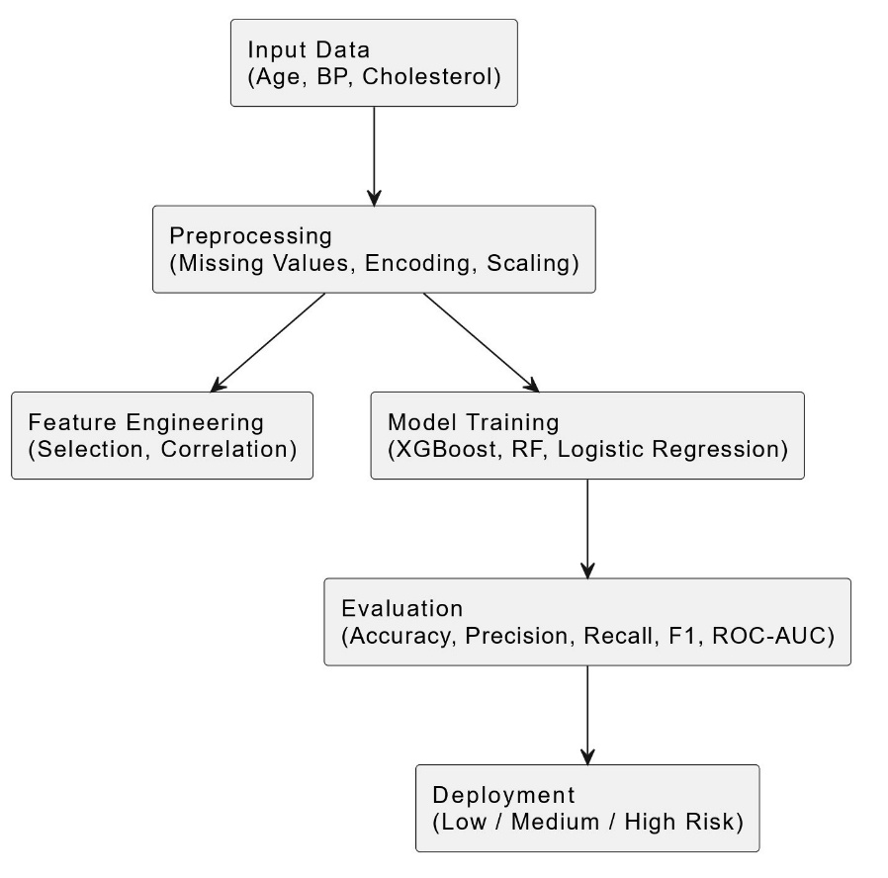
Right off, the tool focuses on just one job—using details about someone’s daily life and medical background to guess their chances of heart problems. This was developed for this exact purpose. The modeling was done in a stepwise manner in which the model was improved with each step․ Survey variables included age‚ physical activity‚ sleep duration‚ nutrition‚ sex‚ and cardiovascular symptoms․ The unprocessed data contained many missing‚ conflicting‚ and inaccurate entries․ Preprocessed data resulted in removing superfluous features‚ encoding categorical variables‚ and removing duplicates․ An exploratory analysis was conducted into the distributions and correlations of features․ The hyperparameter-tuning XGBoost model was chosen due to its performance with noisy and missing values‚ and its regularization capabilities‚ which prevent overfitting․ The model generated a set of posterior probabilities for each case which were then converted to binary decisions based on the pre-specified probability threshold․ Besides the accuracy of the model‚ a number of other metrics were monitored during model building‚ including precision‚ recall‚ F1-score‚ and ROC-AUC․ To ease the interpretability of the models‚ SHAP (SHapley Additive exPlanations) values were used to allow the user to discern how much each feature contributed to each prediction․ The final model was saved in joblib format so that in any subsequent work the model would not have to be retrained․ As shown in Figure. 1‚ the proposed framework achieves a trade-off between prediction performance and interpretability‚ with interpretability being a major requirement for clinical decision support systems․

Figure. 1. System Architecture for cardiovascular Disease Prediction
- Methodology
The model was constructed in an iterative manner‚ with the individuals responding to a structured electronic questionnaire related to their health behavior and general lifestyle habits․ When the desired number of responses was collected‚ the data was exported in CSV format․ In the first stage of data analysis‚ missing values‚ inconsistencies‚ unclear answers and similar issues were identified․ Binary (yes/no) values were automatically recoded into the numeric format required by machine learning algorithms․ An exploratory data analysis (EDA) was conducted where data distributions‚ correlations‚ and other patterns related to relationships between variables were analyzed․ The results of the EDA were used to generate additional features․ The model was evaluated with stratified K-fold cross-validation (k = 5) to avoid overfitting․ This means the data was divided into five subsets or folds‚ and the model was evaluated in turn using one fold as the test set and the remaining folds as the training set․ The model performance was averaged across the five folds․ The Mathematical Formulation of XGBoost is:
$\hat{y_{i}}=\sum_{k=1}^{K}{f_{k}\left(x_{i}\right)}$ (1)
XGBoost creates the final prediction by arranging outputs from several trees.

- Result and Discussion
A number of metrics were used to evaluate the model because accuracy alone is not always considered an appropriate measure of performance for a medical use case․ The model was found to have an approximately 90-95% accuracy‚ with additional measures including precision‚ recall and F1-score being used as well․ Overall‚ the results showed that the model was able to accurately classify individuals through the full scale‚ with relatively few false positives or false negatives․ This indicated that the model was able to identify at-risk individuals without bias․ Additionally‚ the confusion matrix indicated that the misclassifications were random․ Furthermore‚ the Receiver Operating Characteristic - Area Under Curve (ROC-AUC)‚ which indicates the model's ability to discriminate between the outcome classes independent of the selected classification threshold‚ was high․ Finally‚ since it is paramount to minimize the number of false negatives in a clinical setting‚ the recall was consistently high․ Table 1 shows the classification results․ The baseline models (Logistic regression‚ Random Forest‚ and Artificial Neural Network) were trained and the results were compared to the results of the proposed model․ The models are summarized in Table 2․
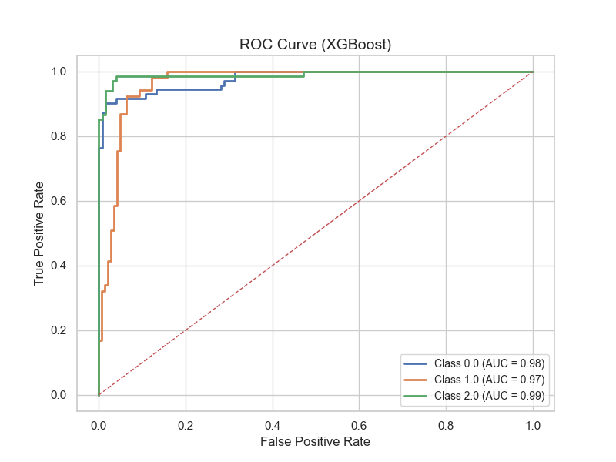
Figure. 2 – ROC AUC Curve
Class | Precision | Recall | F1-Score | Support
Class 0 | 0.97 | 0.90 | 0.94 | 72
Class 1 | 0.79 | 0.94 | 0.86 | 53
Class 2 | 0.97 | 0.90 | 0.93 | 68
accuracy |  |  | 0.91 | 193
macro avg | 0.91 | 0.91 | 0.91 | 193
weighted avg | 0.92 | 0.91 | 0.91 | 193

Table 1. Classification Report
Model | Accuracy | Precision | Recall | F1-Score
Logistic Regression | 0.85 | 0.83 | 0.84 | 0.83
Random Forest | 0.88 | 0.87 | 0.86 | 0.86
Artificial Neural Network | 0.89 | 0.88 | 0.87 | 0.87
XGBoost (Proposed) | 0.91 | 0.92 | 0.91 | 0.91

Table 2. Comparative Analysis of Classification Models

- Conclusion

Findings from this research indicate that it is possible and effective to predict cardiovascular risk from simple self-reported survey data with the help of machine learning techniques. More efforts were devoted to data preprocessing and exploratory analysis, which turned out to be very helpful in finding features of interest and improving the quality of data. Among the different models used in the study, the XGBoost model stood out from the crowd by consistently showing very good and dependable performance throughout validation processes. Besides reliably detecting who was likely to suffer, the model also made very few critical mistakes, especially false negatives, which from the point of view of clinicians, are most undesirable. In other words, the model relies heavily on simple, self-report health information, which is usually readily available in early risk detection situations and health resource-poor settings. In light of this, such strategies even if they are of the basic level hold great promise in preventive medicine to aid in the early identification of cardiovascular risk long before the occurrence of major events.

- Further work
This study has some limitations that need to be acknowledged so that they can be taken into account in future researches. The dataset that was used is really special; however, it is a bit small, so the model can only learn the features of a limited number of people. To make the model more general and robust, the author could consider increasing the dataset with people from different backgrounds. Moreover, one of the limitations is the dependence on self-report which may sometimes lead to errors in the data because individuals' responses are based on their awareness, memory and also whether they want to disclose the information. Such things can lead to the collection of partial or biased data, and that is what the model will learn and therefore its predictions will be influenced. Including other sources of data such as clinical measurements or data from wearable devices would be a step in the right direction for having more reliable and stable input data. The XGBoost model led very high-performance results but it is not necessarily the best method. The latest deep learning models might improve at spotting complex feature connections, but it seems a structured side-by-side analysis is still needed. Right now, the system doesn't prioritize user experience, designing for simplicity and compatibility with basic hardware could dramatically boost adoption in real-world applications. SHAP does make explanations more transparent, yet arguably the biggest challenge ahead is how to present model outputs so ordinary users can grasp them without technical training.

References
[1] World Health Organization, “cardiovascular diseases in India”, WHO India, 2024. [Online]. Available: https://www.who.int/india/health-topics/cardiovascular-diseases
[2] World Health Organization, “cardiovascular diseases (CVDs)”, WHO, 2025. [Online]. Available: https://www.who.int/news-room/fact-sheets/detail/cardiovascular-diseases-(cvds)
[3] A. Singh and R. Kumar, “heart disease prediction using machine learning algorithms,” Proc. IEEE ICE3, 2020.
Available: https://ieeexplore.ieee.org/document/9122989
[4] R. Pillai and S. Sivathanu, “A review of machine learning techniques in healthcare applications,” IEEE, 2020.
Available: https://ieeexplore.ieee.org/document/9143981
[5] S. Mohan, C. Thirumalai, and G. Srivastava, “Effective heart disease prediction using hybrid machine learning techniques,” IEEE Access, vol. 7, pp. 81542–81554, 2019. Link: https://doi.org/10.1109/ACCESS.2019.2923707
[6] K. Budholiya, S. Shrivastava, and V. Sharma, “An optimized XGBoost based diagnostic system for effective prediction of heart disease,” Journal of King Saud University - Computer and Information Sciences, 2022.
Available: https://doi.org/10.1016/j.jksuci.2020.10.013
[7] X. Gao et al., “Improving accuracy of heart disease prediction using ensemble methods,” Complexity, 2021. Link: https://doi.org/10.1155/2021/6663455
[8] A. Tiwari et al., “An ensemble framework for cardiovascular disease prediction,” arXiv, 2023.
Link: https://arxiv.org/abs/2306.09989
[9] J. Yang et al., “A new framework for heart disease prediction using SMOTE-XGBoost,” Information, vol. 13, no. 10, 2022. Available: https://www.mdpi.com/2078-2489/13/10/475
[10] A. Chakraborty et al., “Explainable machine learning for heart disease risk prediction,” Expert Systems with Applications, 2026. Link: https://www.sciencedirect.com/
[11] T. Roopa et al., “heart disease predictive modeling using XGBoost and SMOTE,” Engineering, Technology & Applied Science Research, 2025.
Available: https://www.etasr.com/index.php/ETASR/article/view/14301
[12] A. Surya, “Machine learning and ensemble approach for heart disease prediction,” arXiv, 2021.
Link: https://arxiv.org/abs/2111.08667
[13] X. Gao et al., “Improving accuracy of heart disease prediction using ensemble methods,” Complexity, 2021.
Link: https://doi.org/10.1155/2021/6663455

